CSE488 Deep Learning – Musical Instruments Classification

Prepared by
Ali Khaled 22P0260
Ahmad Sherif 2201075

Abstract
This project focuses on the problem of musical instrument image classification using both classical machine learning and modern deep learning techniques. The baseline objective of the original project was to evaluate traditional machine learning approaches for recognizing musical instruments from images. In this continuation of the project, deep learning models were introduced and compared against the original classical approaches in order to evaluate performance improvements, feature learning capabilities, and generalization.
The project uses image-based classification techniques on a dataset containing multiple categories of musical instruments. Classical machine learning models such as Support Vector Machine (SVM) and Random Forest were implemented using handcrafted Histogram of Oriented Gradients (HOG) features to establish baseline performance. Several deep learning architectures were then introduced, including custom Convolutional Neural Networks (CNNs), regularized CNNs with augmentation and dropout, and transfer learning approaches using MobileNetV2 and EfficientNetB0.
The results demonstrate that deep learning models significantly outperform classical machine learning approaches due to their ability to automatically learn hierarchical image representations. Transfer learning models achieved the best performance overall, showing the effectiveness of pretrained architectures in image classification tasks.

1. Introduction
Image classification is one of the most important applications of computer vision and artificial intelligence. Musical instrument recognition is a challenging classification problem because instruments may vary in shape, orientation, lighting conditions, background complexity, and visual similarity between classes.
The original baseline of this project focused on evaluating classical machine learning methods for musical instrument classification. In that phase, handcrafted feature extraction techniques were used together with traditional classifiers. The goal of the continuation project was to extend the system using deep learning models and compare their performance with the baseline classical approaches.
This project therefore investigates the following:
- Performance of classical machine learning models on musical instrument classification.
- Performance of deep learning models trained from scratch.
- Effect of regularization techniques such as augmentation and dropout.
- Performance of transfer learning architectures.
- Comparative analysis between traditional and deep learning approaches.

2. Project Objectives
The main objectives of this project are:
- Build a complete musical instrument image classification pipeline.
- Implement classical machine learning baseline models.
- Extract handcrafted image features using HOG descriptors.
- Train and evaluate SVM and Random Forest classifiers.
- Implement custom CNN architectures using TensorFlow/Keras.
- Improve CNN generalization using augmentation and dropout.
- Apply transfer learning using pretrained deep learning models.
- Compare all models using accuracy and confusion matrices.
- Analyze strengths and weaknesses of each approach.

3. Dataset Description
The project uses the Musical Instruments Image Classification dataset downloaded using KaggleHub.
The dataset contains labeled images of different musical instruments. Each image belongs to one instrument category. The dataset includes various image conditions, making the classification problem more realistic.

Dataset Characteristics
The dataset is organized into three standard splits:
- Training: Model weight optimization
- Validation: Hyperparameter tunning and early stopping
- Test: Final performance evaluation

The following 30 instrument classes span a wide acoustic and visual variety — from large orchestral instruments to small folk instruments — making this a genuinely hard fine-grained classification task:

# | Class Name | # | Class Name | # | Class Name
1 | Didgeridoo | 11 | Clarinet | 21 | Marakas
2 | Tambourine | 12 | Clavichord | 22 | Ocarina
3 | Xylophone | 13 | Concertina | 23 | Piano
4 | Accordion | 14 | Drums | 24 | Saxophone
5 | Alphorn | 15 | Dulcimer | 25 | Sitar
6 | Bagpipes | 16 | Flute | 26 | Steel Drum
7 | Banjo | 17 | Guiro | 27 | Trombone
8 | Bongo Drum | 18 | Guitar | 28 | Trumpet
9 | Casaba | 19 | Harmonica | 29 | Tuba
10 | Castanets | 20 | Harp | 30 | Violin

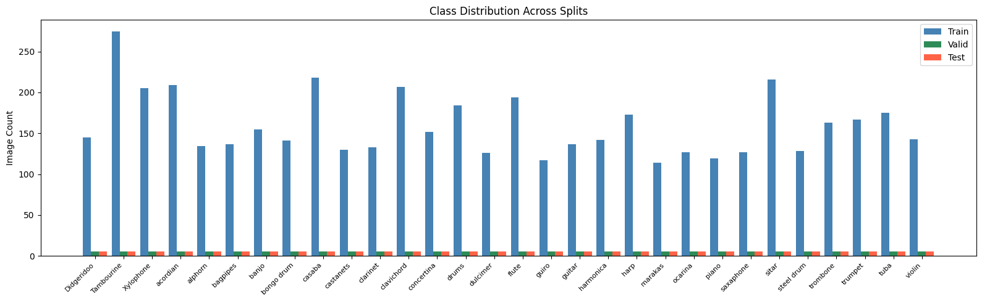

Preprocessing Steps
The following preprocessing steps were applied:
- Image resizing to 128 × 128.
- Normalization of pixel values.
- Dataset splitting.
- Feature extraction for classical models.
- Data augmentation for CNN training.

4. Exploratory Data Analysis (EDA)
Exploratory Data Analysis was performed before model training to better understand the dataset distribution and image characteristics.
The EDA stage included:
- Visualization of sample images from each class.
- Inspection of dataset balance.
- Analysis of image dimensions.
- Visualization of HOG feature representations.
EDA helped verify the integrity of the dataset and provided insight into how different instruments appear visually.

5. Baseline Classical Machine Learning Models
The baseline implementation of this project relied on classical machine learning techniques.
Unlike deep learning models, classical approaches cannot directly learn features from raw images. Therefore, handcrafted feature extraction techniques were necessary.

5.1 HOG Feature Extraction
Histogram of Oriented Gradients (HOG) was used to extract visual features from images.
HOG captures:
- Edge structures
- Object shapes
- Gradient orientations
- Texture information
These descriptors transform images into numerical feature vectors suitable for machine learning classifiers.

Advantages of HOG
- Computationally efficient.
- Effective for shape-based recognition.
- Works well with traditional ML algorithms.

Limitations of HOG
- Cannot learn complex hierarchical representations.
- Sensitive to rotation and scale variations.
- Limited adaptability compared to CNNs.

5.2 Support Vector Machine (SVM)
A Support Vector Machine with RBF kernel was implemented as one of the baseline models.

Why SVM?
SVM is a strong traditional classifier for image recognition tasks because it:
- Works well in high-dimensional spaces.
- Handles non-linear classification using kernels.
- Performs effectively on medium-sized datasets.

SVM Pipeline
- Extract HOG features.
- Train SVM classifier.
- Predict instrument classes.
- Evaluate classification accuracy.

Advantages
- Strong baseline performance.
- Effective decision boundaries.
- Good generalization.

Limitations
- Depends heavily on handcrafted features.
- Training becomes expensive for large datasets.
- Cannot automatically learn representations.

5.3 Random Forest
Random Forest was implemented as another classical baseline model.
Random Forest is an ensemble learning method that combines multiple decision trees.

Why Random Forest?
- Handles non-linear decision boundaries.
- Robust against overfitting.
- Easy to train and interpret.

Random Forest Pipeline
- Extract HOG features.
- Train multiple decision trees.
- Aggregate predictions.
- Evaluate performance.

Advantages
- Robust ensemble model.
- Handles noisy features.
- Lower risk of overfitting.

Limitations
- Still depends on handcrafted features.
- Less effective than deep learning on complex image tasks.
- Cannot learn spatial image hierarchies.

6. Deep Learning Models
The continuation of the project introduced deep learning approaches to improve classification performance.
Deep learning models automatically learn features directly from images, eliminating the need for manual feature engineering.
The following deep learning models were implemented:
- Plain CNN
- Regularized CNN
- MobileNetV2 Transfer Learning
- EfficientNetB0 Transfer Learning

7. Plain CNN Model
The first deep learning model implemented was a custom CNN built from scratch.

Architecture Overview
The model follows a VGG-style architecture using:
- Convolutional layers
- ReLU activation
- Max pooling
- Fully connected dense layers
- Softmax output layer

Training Configuration
- Early stopping
- Learning rate reduction
- Validation monitoring

Advantages
- Learns image features automatically.
- Captures spatial patterns.
- Better representation learning than classical ML.

Limitations
- More prone to overfitting.
- Requires larger training data.
- Higher computational cost.

8. Regularized CNN
To improve generalization and reduce overfitting, a regularized CNN was implemented.

Regularization Techniques Used

1. Data Augmentation
Data augmentation artificially increases training diversity by applying:
- Rotation
- Flipping
- Zooming
- Shifting
This improves model robustness.

2. Dropout
Dropout randomly disables neurons during training to prevent over-reliance on specific features.

Improvements Over Plain CNN
- Better generalization.
- Reduced overfitting.
- More stable validation accuracy.

9. Transfer Learning Models
Transfer learning was introduced to leverage pretrained models that were originally trained on large image datasets such as ImageNet.
Transfer learning provides significant advantages:
- Faster convergence.
- Better feature extraction.
- Higher accuracy.
- Reduced training time.

9.1 MobileNetV2
MobileNetV2 is a lightweight deep learning architecture optimized for efficiency.

Characteristics
- Low computational cost.
- Efficient architecture.
- Suitable for real-time systems.

Benefits in This Project
- Strong performance.
- Faster training.
- Better feature extraction than handcrafted methods.

9.2 EfficientNetB0
EfficientNetB0 was implemented as the most advanced transfer learning model in the project.

Characteristics
- Compound scaling approach.
- Optimized depth, width, and resolution.
- High accuracy with efficient computation.

Benefits in This Project
- Best overall performance.
- Superior feature representation.
- Strong generalization capability.

10. Model Evaluation
The models were evaluated using classification accuracy and confusion matrices.

Evaluation Metrics

Accuracy
Measures the percentage of correctly classified images.

Confusion Matrix
Provides detailed insight into:
- Correct predictions
- Misclassifications
- Class confusion patterns

11. Comparative Analysis
The project compared classical machine learning models with deep learning approaches using test accuracy as the primary evaluation metric.

Final Model Results
Model | Approach Type | Test Accuracy
HOG + Random Forest | Classical Machine Learning | 45.83%
HOG + SVM (RBF) | Classical Machine Learning | 57.90%
Plain CNN | CNN from Scratch | 60.67%
CNN + Augmentation + Dropout | Regularized CNN | 62.67%
MobileNetV2 (Transfer Learning) | Transfer Learning | 97.33%
EfficientNetB0 (Transfer Learning) | Transfer Learning | 99.00%

Result Analysis

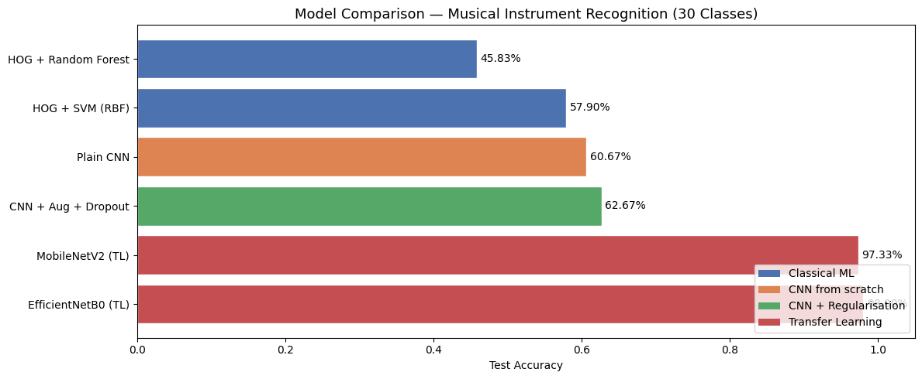

Classical Machine Learning Performance
The classical machine learning models produced the lowest overall accuracies in the project.

HOG + Random Forest — 45.83%
The Random Forest classifier achieved the lowest performance among all tested models. Although Random Forest is a robust ensemble method, its performance was limited by the quality of handcrafted HOG features. The model struggled to capture complex visual patterns and fine-grained differences between musical instruments.

HOG + SVM (RBF) — 57.90%
The SVM classifier significantly outperformed Random Forest and provided a stronger classical machine learning baseline. The RBF kernel enabled better non-linear separation between classes, making SVM more suitable for image classification tasks. However, performance was still constrained by handcrafted feature extraction.

CNN from Scratch Performance

Plain CNN — 60.67%
The plain CNN slightly outperformed the SVM baseline, demonstrating the advantage of automatic feature learning over handcrafted HOG descriptors. Even without advanced regularization or transfer learning, the CNN learned useful spatial image representations directly from raw pixels.
However, the improvement over SVM was relatively modest, suggesting that the model still faced challenges such as overfitting and limited generalization.

Regularized CNN Performance

CNN + Augmentation + Dropout — 62.67%
Adding regularization techniques improved performance compared to the plain CNN.
The improvement demonstrates the importance of:
- Data augmentation for increasing dataset diversity.
- Dropout for reducing overfitting.
- Better generalization on unseen data.
Although the accuracy gain was moderate, the model became more stable and generalized better than the plain CNN.

Transfer Learning Performance

MobileNetV2 (Transfer Learning) — 97.33%
MobileNetV2 produced a dramatic improvement in accuracy compared to all previous models.
This result highlights the effectiveness of transfer learning, where pretrained ImageNet knowledge enables the model to extract highly informative visual features. The model achieved near-perfect classification while remaining computationally efficient.
The large performance jump from approximately 62% to 97% demonstrates how pretrained architectures outperform both handcrafted feature engineering and CNNs trained from scratch.

EfficientNetB0 (Transfer Learning) — 99.00%
EfficientNetB0 achieved the highest accuracy in the project and delivered the best overall performance.
Its advanced compound scaling strategy enabled superior feature extraction and representation learning. The model was highly effective at distinguishing between visually similar instruments and achieved almost perfect classification accuracy.
This result confirms that modern transfer learning architectures are extremely powerful for computer vision tasks, even when trained on relatively limited datasets.

Overall Comparison
The results clearly show a progression in performance across the different approaches:
- Classical machine learning models achieved the lowest performance.
- CNNs trained from scratch improved feature learning capabilities.
- Regularization improved CNN generalization.
- Transfer learning models dramatically outperformed all other methods.
- EfficientNetB0 achieved the best overall accuracy.
The results also demonstrate the evolution from traditional feature engineering toward modern end-to-end deep learning systems.

Key Observations
- SVM outperformed Random Forest among the classical ML approaches.
- CNNs automatically learned better image representations than HOG features.
- Regularization techniques improved CNN stability and reduced overfitting.
- Transfer learning provided extremely large accuracy improvements.
- EfficientNetB0 was the most effective architecture in the project.

12. Discussion
The experiments clearly demonstrate the transition from traditional machine learning to modern deep learning approaches.

Key Findings
- Deep learning models significantly outperform classical ML models.
- Transfer learning achieves the best results due to pretrained knowledge.
- Regularization techniques improve CNN stability.
- Handcrafted features are less effective than learned features.
- EfficientNetB0 provided the strongest overall performance.

Why Deep Learning Performed Better
Deep learning models automatically learn:
- Shapes
- Edges
- Textures
- Spatial relationships
- High-level semantic features
In contrast, classical ML approaches rely entirely on manually engineered features such as HOG.

13. Challenges Faced
Several challenges were encountered during the project:
- Computational requirements for training CNNs.
- Preventing overfitting.
- Hyperparameter tuning.
- Dataset variability.
- Balancing training efficiency and accuracy.
These challenges were addressed using:
- Early stopping
- Dropout
- Learning rate scheduling
- Data augmentation
- Transfer learning

14. Technologies and Libraries Used
The project used the following tools and libraries:

Programming Language
- Python

Libraries
- TensorFlow
- Keras
- Scikit-learn
- NumPy
- Pandas
- Matplotlib
- OpenCV
- KaggleHub

15. Conclusion
This project successfully extended a baseline classical machine learning system into a comprehensive deep learning musical instrument classification framework.
The baseline models, SVM and Random Forest, provided an important benchmark for evaluating the effectiveness of deep learning approaches. While the classical models achieved reasonable results using HOG features, they were limited by their dependence on handcrafted feature extraction.
The introduction of deep learning models dramatically improved performance. Custom CNNs demonstrated the power of automatic feature learning, while regularization techniques improved generalization and reduced overfitting. Transfer learning models, especially EfficientNetB0, achieved the highest classification performance due to their pretrained visual knowledge and advanced architectures.
Overall, the project demonstrates how modern deep learning techniques can substantially outperform traditional machine learning methods in computer vision tasks such as musical instrument recognition.

16. Future Work
Possible future improvements include:
- Using larger and more diverse datasets.
- Applying Vision Transformers (ViTs).
- Real-time webcam instrument recognition.
- Audio-based instrument classification.
- Multi-modal learning using both image and audio.
- Model deployment as a web or mobile application.
- Hyperparameter optimization.
- Ensemble deep learning systems.

